HackTheBox Academy

Network Enumeration with Nmap module

Course: Junior Cybersecurity Associate

Host and Port scanning.

Nmap is an open source scanning tool used to scan networks and identify which hosts are available on the network using raw packets, services and application.
In this section we were given two tasks:

- Find all TCP ports on a target and submit the total open ports found;
- Enumerate the hostname on the target and submit it as the answer.

Before completing the tasks we first connect to HackTheBox’s lab network vpn.
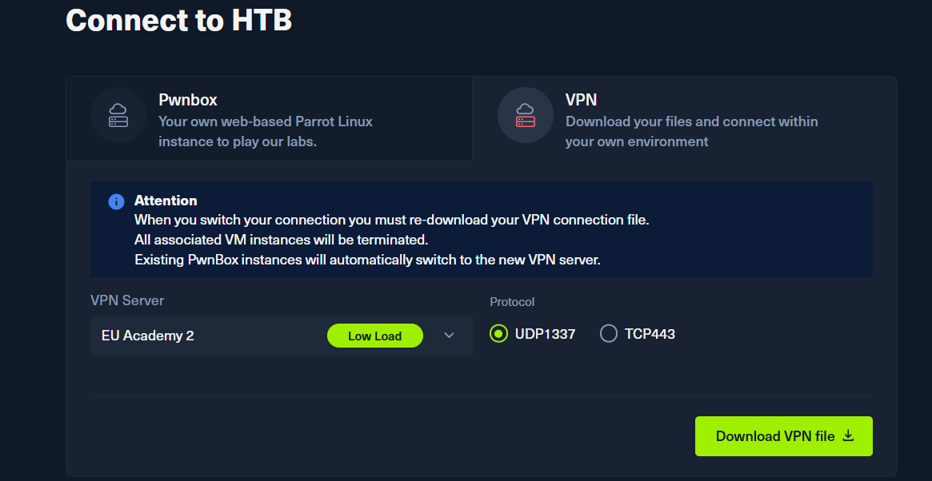
In order to do that we download the VPN file in the lower section of the topic’s page

After downloading we use a command: sudo openvpn <file name>.ovpn
The command will open the vpn and we know we are connected if it says: Initialization Sequence Complete

1.Find all TCP ports on a target and submit the total open ports found.

We first spawn HackTheBoxe’s target IPv4 address which was: 10.129.151.73
This is the address we will use for our tasks.

So in order to find all TCP ports on the 10.129.151.73 IPv4 address we will type a command: sudo nmap 10.129.151.73 -sS
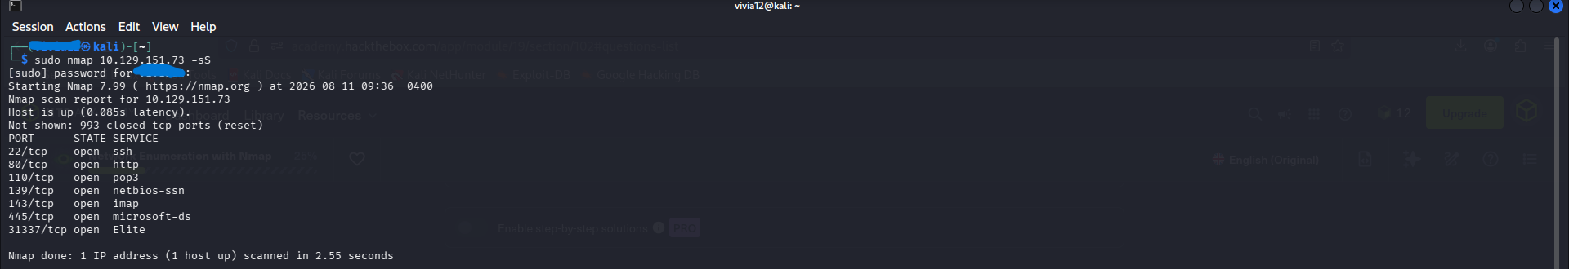
-sS is a SYN scan that scans the first one thousand ports.
In the screenshot we see that the answer is 7, because there are 7 open ports, that the scan has found.

2. Enumerate the hostname on the target and submit it as the answer.

In order to enumerate the hostname on the target, we will use Nmap’s -sV option, that is used to get additional information from those ports as it does a reverse DNS lookup and retrieves information such as hostname, service names and other details about the target. During this section I was unsure about the command which is correct so this command was found on a Medium write up by: H3rCul3s

The command that is used most commonly is: sudo nmap 10.129.151.73 -sV - - script dns-brute
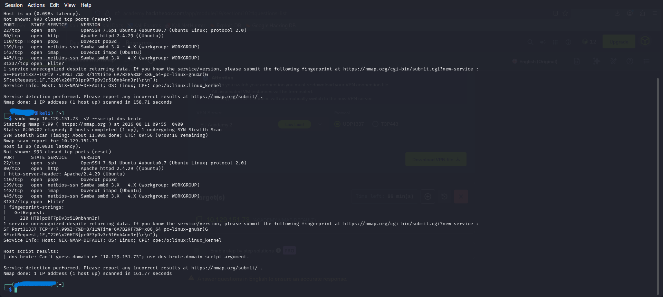

--script – Nmap during/after the scan runs a particular NSE script to obtain more information.
Dns-brute – a particular script that tries to discover DNS hostnames/subdomains.
So the answer is: NTX-NMAP-DEFAULT

